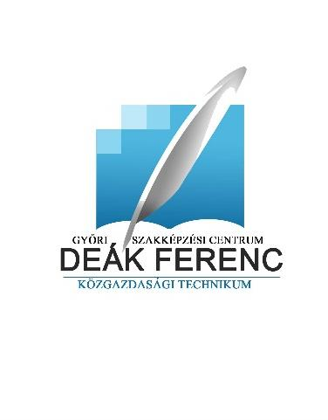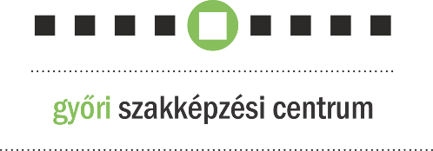





**Invitation**

for a Transnational Practice Enterprise Conference and Trade Fair



**The Győr Vocational Educational Center Deak Ferenc Secondary School of Economics**

**and**

**the Foundation for the Deak Ferenc Secondary School of Economics**

cordially invites you

on 10th December

starting at 10.00am

for its

**transnational conference**

**Patron of the event:**

**Dr. Zita Magyar,**

president of the National Vocational and Adult Education Bureau

**Venus:**

Győr-Moson-Sopron County Chamber of Commerce and Industry

Large Hall

(9021 Győr, Szent István u. 10/a.)

Participation in the conference is free of charge,

but registration is required.

Deadline for registration:

30th November 2024.

e-mail: [iskola@deakgyor.hu](mailto:iskola@deakgyor.hu)

phone.: 96/312-135

Parking facility:

Révai parking garage

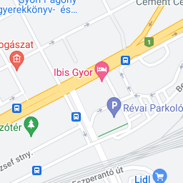

**Program:**

**9:30-10:00**

**Registration**

**Opening of the event by:**

**Albert Molnár,**

regional president of the Győr-Moson-Sopron County Chamber of Commerce and Industry

**Welcome speeches by:**

**Dr. ZitaMagyar,**

president of the National Vocational and Adult Education Bureau

**Eszter Gede,**

*chancellor of the Győr Vocational Educational Center*

**Presentations:**

**10:00-11:00**

**Implementing an Interreg project – vocational training and innovation**

*by: Anett Kocsis, vice-principal of the Győr Vocational Educational Center Deak Ferenc Secondary School of Economics*

*Board of Trustees member*

**Transnational relations at Deak School**

*by: Ágnes Kovácsné Zimborás, principal of the Győr Vocational Educational Center Deak Ferenc Secondary School of Economics,*

*Chairperson of the board of trustees*

**Cross-border relations as opportunities of innovation in vocational education**

*by: Péter Varga, principal of Karva Secondary Technical School of Commerce, Service and Rural Development*

**The role of transnational relations in the life of IPOSZ, a representation of the interests of SMEs organization**

*by: Tamás Rettich, Senior Advisor on international relations at IPOSZ*

**11:00-11:15**

Break, Buffet lunch

**11:15-13:00**

**Sustainable events, Green Event Certifiate**

*by: Zita Zsófia Gáspár, leader of KÖVET Association for a Sustainable Economy programme*

**‘Greening’ at Practice Enterprise Training- introducing a Deak School PE profile**

*by: Ildikó Pelentainé Bálint, vice-principal of the Győr Vocational Educational Center Deak Ferenc Secondary School of Economics*

**Development and Practical Operation of the Practice Enterprise software**

*by: Gábor Takács, managing director of KTS Online Ltd*

**Generations at work**

*by: Dr. Attila Mészáros, Associate Professor at Széchenyi István University*

**Closing thoughts:**

**Ágnes Kovácsné Zimborás,**

*Principal of the Győr Vocational Educational Center Deak Ferenc Secondary School of Economics,*

*Chairperson of the board of trustees*

**Invitation for**

**Transnational Practice Enterprise Trade Fair and Exhibition**

**The Győr Vocational Educational Center Deak Ferenc Secondary School of Economics**

cordially invites you

on 11th December

starting at 10.00am

for its

**Transnational Practice Enterprise Trade Fair and Exhibition**

event

**Venue:**

Széchenyi University Apáczai Faculty Gym Hall

(9022 Győr, Liszt Ferenc utca 42.)

Request for interest to participate

by 30th November 2024

and details of the exhibition

on www.taniroda.hu